Squash

News and Info:
2012 National Squash tournament 4 - 6th May 2012 - To register please click here.

Up-Coming Events:
The 2012 NZFS National Squash Tournament is being Co-hosted by the New Plymouth Fire Brigade and the New Plymouth West Volunteer Fire Brigade and is being held at the
Kawaroa Park Squash Club, Tisch Ave, New Plymouth on:
4 - 6th May 2012
(Please note: Games are scheduled for Friday evening, Saturday and Sunday)
Registration Fees: Team of 4: $200.00 per team. | 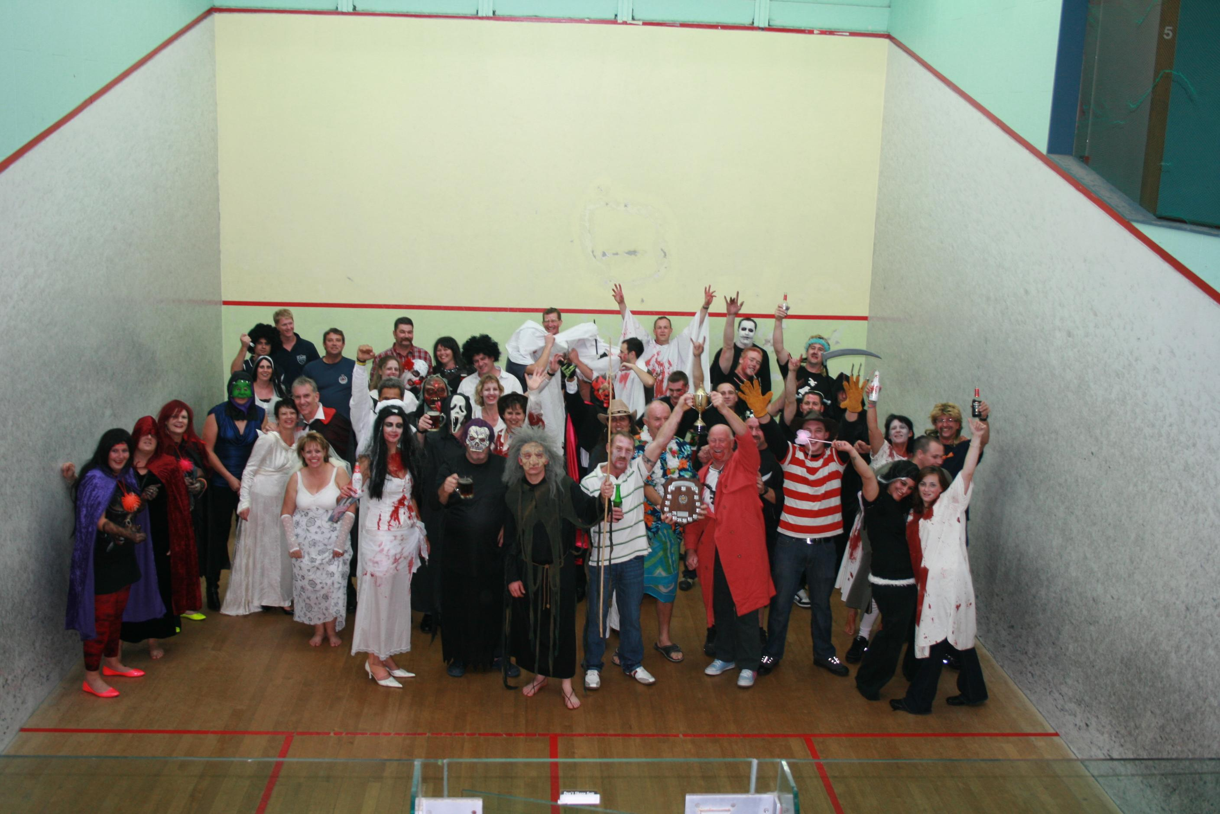
Cheques made payable to: NZFS Squash Tournament or alternatively pay directly via TSB Interbank Number 55-0536434-00

Registration is STRICTLY LIMITED to 20 teams of 4 on a first in, first served basis.

Registrations close on FRIDAY 20th April 2012
Participation in the tournament is open to all current NZFS/UFBA members, past members, spouses and partners. Food and a full bar facility available from tournament venue all weekend.
EFTPOS AVAILABLE AT CLUB
Please Post completed registration form (found here) including the Entry Fee to:
Rachael Lind
Co-director
NZFS National Squash Tournament 2012
New Plymouth Fire Brigade
PO Box 747
New Plymouth

Friday 4th May:
Welcome/registration/draw/ opening round/s - 5pm (sharp) at the Kawaroa Park Squash Club. Followed by liquid refreshments and fellowship

SATURDAY 5th May:
Play starts at 8.30am sharp
Saturday night function (Kawaroa Park Squash Club) Pre-dinner drinks from 6.30 pm
THEME: Bollywood Dinner and Show (Entry fee includes your dinner and the show)
• Buy your own booze/drinks (Cash bar, Eftpos available)
• Bollywood dress up compulsory, prize for best costume
Sunday 6th May:
Play starts at 9am sharp (Finals)
Prize giving (Approximately Mid afternoon)
Accomodation:
All teams are responsible for booking and arranging their own accommodation requirements. For accommodation options please support our tournament sponsor: Michael and Christine Hickford at:
New Plymouth Top 10 Holiday Park at www.nptop10.co.nz for affordable, clean and friendly accommodation options.
Travel:
All teams are responsible for their own transport arrangements to and from the tournament venue and their respective accommodations.
Contact Details: Tournament Co- Directors
Rachel Lind: rachel.lind@fire.org.nz Phone: 0211596898
Sam Bennett: sam.bennett@mando.net.nz Phone: 0277515733

Results:

