Soccer
The beautiful game, some say it's poetry in motion. A great sport for all ages and skill levels and a lot of fun to be had. Check here for all Fire Service related soccer info, events tournaments and results.
News and Info:
NZFS 7 A-SIDE TOURNAMENT 2012 DATE - November 1st - 3rd. Venue is Tremain Field, Park Island Napier.
Thursday 1 November - Managers meeting and get together
Friday 2nd November 2012 - pool play
Saturday 3rd November 2012 - Finals
Google Map of Tremain Field: Click Here
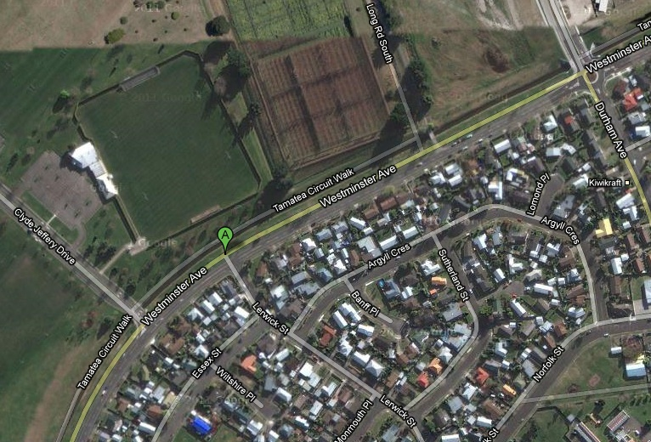
Interested in playing Sunday social football in the Wellington region? the "NZFS Wildfire" sunday social soccer team based in the Hutt is looking for members. All current Fire Service personnel: Operational, Non-Operational and Volunteer are eligible. Games are played all around the wellington region. Contact Andrew Hansford Andrew.Hansford@fire.org.nz for details.

Up-Coming Events:
NZFS 7 a-side Tournament November 1st - 3rd, 2012 - Napier. Contact Tony Adie Tony.Adie@fire.org.nz OR Brent Marshall Brent.Marshall@fire.org.nz

NZFS NATIONAL 7-a-side SOCCER TOURNAMENT
NAPIER 2012
Napier Fire Brigade is hosting the NZFS national 7-a-side soccer tournament on 1 - 3 November 2012.
Games will be held at Tremain Field, Park Island, Napier, over two days:
Friday – pool play
Saturday – Quarters/Semis/Finals
Social functions will be held at Napier Fire Station canteen:
€€€€• Thursday night – get together, registration and managers meeting
€€€€• Friday night – player of the day awards, BBQ and party
€€€€• Saturday – dinner, prizegiving and party
Eftpos will be available at the canteen during the tournament.
A mobile espresso coffee cart will be at the ground each day. Food and Cold drinks will also be available to purchase at the ground. A courtesy van will be operating each evening to and from the canteen. The Thirsty Whale double decker bus will be running from the canteen to the central city and West Quay late Saturday night.
Tournament Rules:
Can be found Here

Results:
2006 - Air Force Fire
2007 - Wellington 1
2008 - Rotorua
2009 - Palmerston North 1
2010 - Palmerston North 1
2011 - Hawkesbay 1

